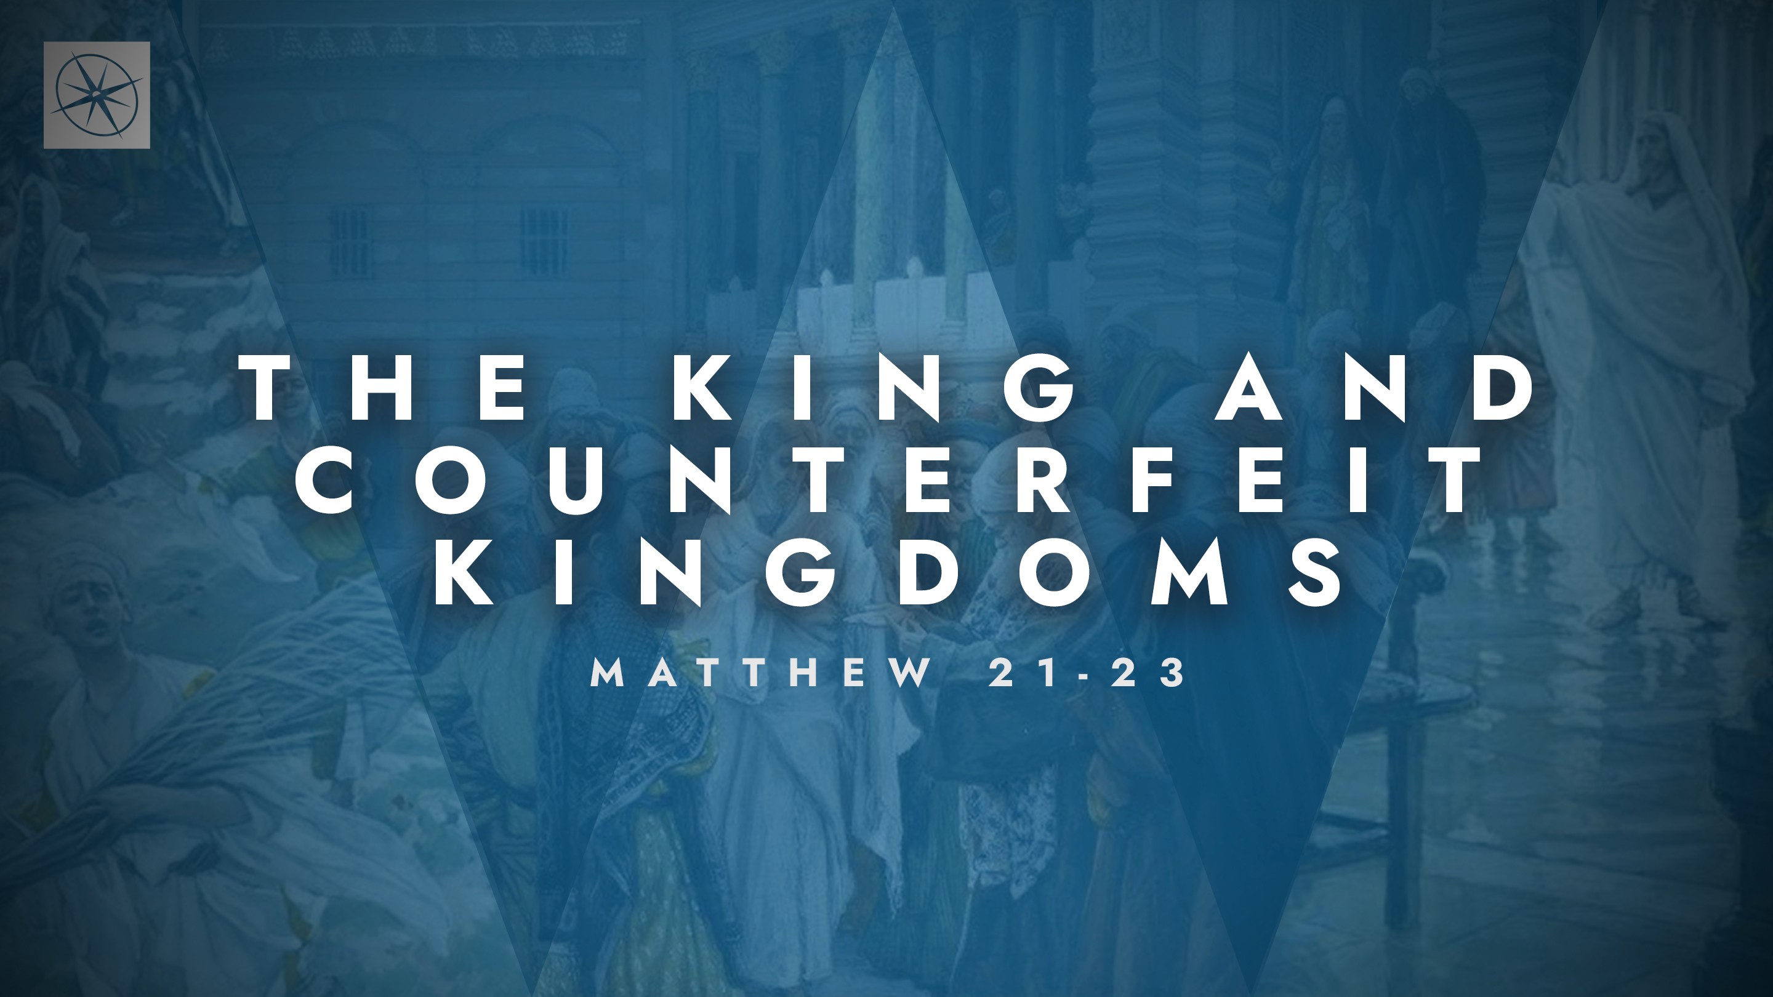
THE KING AND COUNTERFEIT KINGDOMS
FIGS AND FAITH
Pastor Hayden Thomas • Compass Bible Church Hill Country • April 19, 2026 • Msg. 26-15

PREACHING POINT: The words of Jesus should prompt us to consider the judgment awaiting all forms of counterfeit faith while encouraging us with the powerful effects of genuine faith in God.

Matthew 21:18–22 (ESV)
18 In the morning, as he was returning to the city, he became hungry. 19 And seeing a fig tree by the wayside, he went to it and found nothing on it but only leaves. And he said to it, “May no fruit ever come from you again!” And the fig tree withered at once. 20 When the disciples saw it, they marveled, saying, “How did the fig tree wither at once?” 21 And Jesus answered them, “Truly, I say to you, if you have faith and do not doubt, you will not only do what has been done to the fig tree, but even if you say to this mountain, ‘Be taken up and thrown into the sea,’ it will happen. 22 And whatever you ask in prayer, you will receive, if you have faith.”

- Grasp _____________________________ (vv.18-19)

- Expect _____________________________ (vv.20-22)
Application Questions
These questions are provided for your further study and application of today’s sermon. Thoughtfully writing out the answers to these questions will help to drive home the point of today’s study. It is also helpful when you are able to discuss your answers with others. For more information about LifeGroups at Compass Bible Church that utilize these questions as the basis for their weekly discussion, please visit compasshillcountry.org/lifegroups or email us at info@compasshillcountry.org.

- Write down one observation or application you found helpful from this week’s sermon. Why did it stand out to you?
This Week’s
Bible Reading Schedule
April 19th
1 Sam 27-29 & Luke 17:1-19
April 20th
1 Sam 30-31 & Luke 17:20-37
April 21st
2 Sam 1-3 & Luke 18:1-17
April 22nd
2 Sam 4-6 & Luke 18:18-43
April 23rd
2 Sam 7-9 & Luke 19:1-28
April 24th
2 Sam 10-12 & Luke 19:29-48
April 25th
2 Sam 13-14 & Luke 20:1-26
April 26th
2 Sam 15-16 & Luke 20:27-47
See this sermon and all Compass-related videos on YouTube.com/
CompassBibleChurchHillCountry
Subscribe to Weekend Sermons, CompassU & LifeGroup Leader Podcasts: compasshillcountry.org/
podcasts

- Read Amos 5:21-24 and Matthew 15:7-9. Why do you think God rejects outward expressions of counterfeit faith?
  - How can you inspect yourself to make sure you aren’t a fruitless fig tree (Matthew 21:19) or someone who honors God with your lips while your heart is far from God?
- Read Hebrews 11:6, James 1:5-8, and Matthew 21:21-22. Why is doubting, double-minded “faith” evidence of a lack of trust in God’s generosity toward genuine faith?
  - How can double-minded or wavering faith show up in your prayer life? How can you grow in faith-filled prayer?
- Read 1 John 5:14-15. What is the difference between asking God out of selfish desires and asking according to his will?
  - How can you practically grow more confident that what you are asking for is God’s will?
- Read Romans 4:18-21. What can you learn from Abraham’s trust in God’s promises?
  - How can his example shape the way you pray with both confidence and humility this week?
Have a question about this sermon? Send it via the QR code or link below and the pastors will do their best to address it in this week’s EQUIP podcast.

qrco.de/askaquestion

