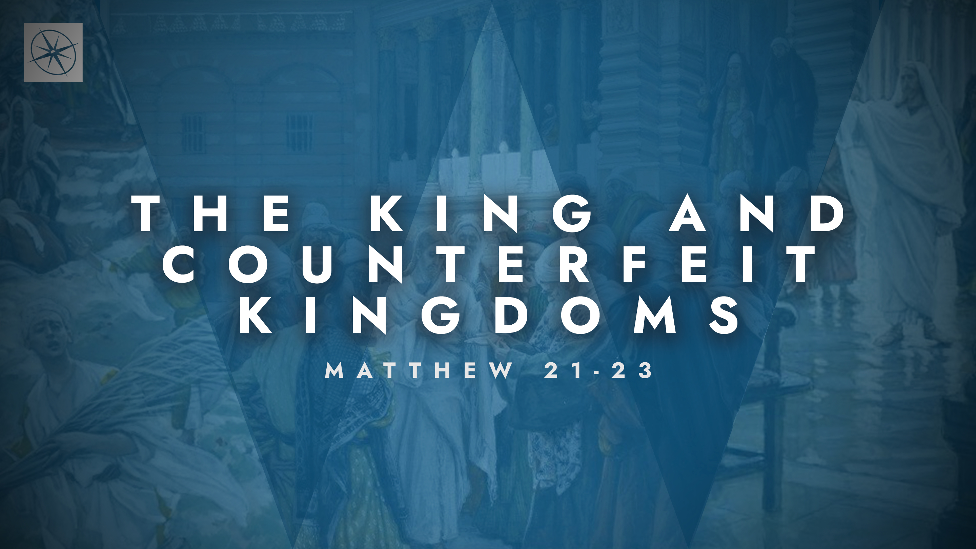
THE KING AND COUNTERFEIT KINGDOMS
CONFRONTING COUNTERFEIT DOCTRINE
Pastor Hayden Thomas • Compass Bible Church Hill Country • June7, 2026 • Msg. 26-21

PREACHING POINT: Jesus’ rebuke must warn us against rejecting biblical truth through faulty reasoning and encourage us to trust God’s power and God’s Word, even when confronted with difficult doctrines.

Matthew 22:23–33 (ESV)
23 The same day Sadducees came to him, who say that there is no resurrection, and they asked him a question, 24 saying, “Teacher, Moses said, ‘If a man dies having no children, his brother must marry the widow and raise up offspring for his brother.’ 25 Now there were seven brothers among us. The first married and died, and having no offspring left his wife to his brother. 26 So too the second and third, down to the seventh. 27 After them all, the woman died. 28 In the resurrection, therefore, of the seven, whose wife will she be? For they all had her.” 29 But Jesus answered them, “You are wrong, because you know neither the Scriptures nor the power of God. 30 For in the resurrection they neither marry nor are given in marriage, but are like angels in heaven. 31 And as for the resurrection of the dead, have you not read what was said to you by God: 32 ‘I am the God of Abraham, and the God of Isaac, and the God of Jacob’? He is not God of the dead, but of the living.” 33 And when the crowd heard it, they were astonished at his teaching.

- Guard _____________________________ (v.23)

- Recognize ___________________________ (vv.24-28)
- Expect ________________________________ (v.29)
- Gladly ______________________________ (vv.30-33)

Application Questions
These questions are provided for your further study and application of today’s sermon. Thoughtfully writing out the answers to these questions will help to drive home the point of today’s study. It is also helpful when you are able to discuss your answers with others. For more information about LifeGroups at Compass Bible Church that utilize these questions as the basis for their weekly discussion, please visit compasshillcountry.org/lifegroups or email us at info@compasshillcountry.org.

- Read Colossians 2:8 and 2 Timothy 4:3–4. What warning signs of theological rebellion do these passages describe?
This Week’s
Bible Reading Schedule
June 7th
2 Chron 23-25 & John 16:16-33
June 8th
2 Chron 26-28 & John 17
June 9th
2 Chron 29-31 & John 18:1-23
June 10th
2 Chron 32-33 & John 18:24-40
June 11th
2 Chron 34-36 & John 19:1-22
June 12th
Ezra 1-2 & John 19:23-42
June 13th
Ezra 3-5 & John 20
June 14th
Ezra 6-8 & John 21
See this sermon and all Compass-related videos on YouTube.com/
CompassBibleChurchHillCountry
Subscribe to Weekend Sermons, CompassU & LifeGroup Leader Podcasts: compasshillcountry.org/
podcasts

  - What doctrines, commands, or biblical positions are you most tempted to downplay, ignore, or explain away?
  - How can you guard against these temptations to keep them from turning into theological rebellion?
- Read 2 Peter 3:14–18 and Romans 1:21–22. Why does rejecting God's truth so naturally produce foolish conclusions?
  - What foolish conclusions have you believed or have been tempted to believe because they seemed more appealing than what Scripture teaches?
- Read Matthew 22:29. Which of these two dangers is a greater threat to you right now: neglecting God's Word or underestimating God's power? Why?
- Read 2 Timothy 3:16–17, Proverbs 3:11–12, and Hebrews 4:12. How does God use his Word, his Spirit and his people to actively rebuke theological foolishness?
  - When have you experienced his Word, his Spirit or his people directly expose wrong thinking in your own life? What happened?
  - How do you typically respond to clear theological correction? How can you grow in your willingness to gladly welcome clear theological correction in the future?
Have a question about this sermon? Send it via the QR code or link below and the pastors will do their best to address it in this week’s EQUIP podcast.

qrco.de/askaquestion

