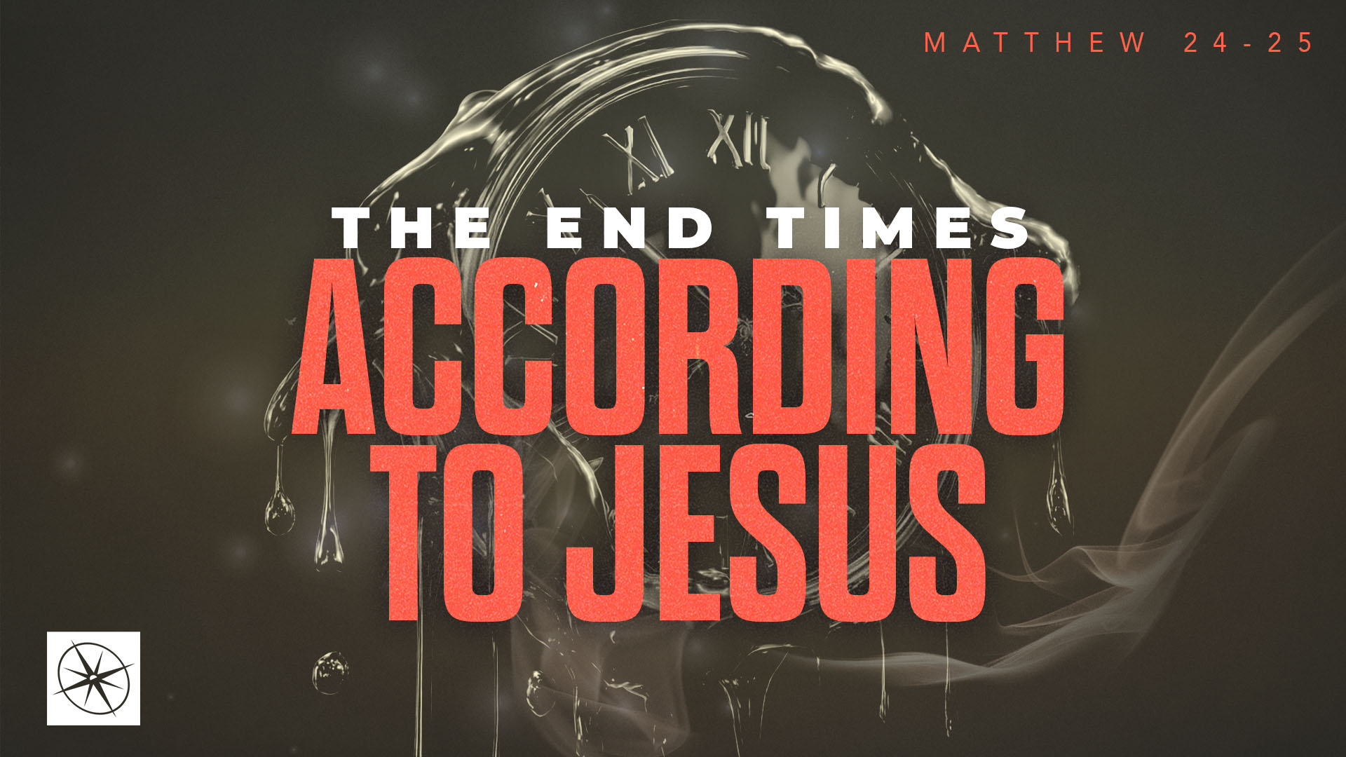
THE END TIMES ACCORDING TO JESUS
THE BEGINNING OF THE END
Pastor Hayden Thomas • Compass Bible Church Hill Country • August 30, 2026 • Msg. 26-32

PREACHING POINT: The worldwide birth pains that precede Christ's return and mark the beginning of God's judgment will not keep the gospel from advancing, but they should remind us to warn others to flee God's wrath by turning from sin and trusting in Christ today, so they will not undergo the Tribulation to come!

Matthew 24:4–14 (ESV)
4 And Jesus answered them, “See that no one leads you astray. 5 For many will come in my name, saying, ‘I am the Christ,’ and they will lead many astray. 6 And you will hear of wars and rumors of wars. See that you are not alarmed, for this must take place, but the end is not yet. 7 For nation will rise against nation, and kingdom against kingdom, and there will be famines and earthquakes in various places. 8 All these are but the beginning of the birth pains. 9 “Then they will deliver you up to tribulation and put you to death, and you will be hated by all nations for my name’s sake. 10 And then many will fall away and betray one another and hate one another. 11 And many false prophets will arise and lead many astray. 12 And because lawlessness will be increased, the love of many will grow cold. 13 But the one who endures to the end will be saved. 14 And this gospel of the kingdom will be proclaimed throughout the whole world as a testimony to all nations, and then the end will come.

- Envision _______________________________ (vv.4-8)
- Grasp ________________________________ (vv.9-13)
- Expect ________________________________ (v.14)

Application Questions
These questions are provided for your further study and application of today’s sermon. Thoughtfully writing out the answers to these questions will help to drive home the point of today’s study. It is also helpful when you are able to discuss your answers with others. For more information about LifeGroups at Compass Bible Church that utilize these questions as the basis for their weekly discussion, please visit compasshillcountry.org/lifegroups or email us at info@compasshillcountry.org.

1. Write down one observation or application you found helpful from this week's sermon. Why did it stand out to you?
This Week’s
Bible Reading Schedule
August 30th
Ps 142-144 & 1 Cor 10:14-33
August 31st
Ps 145-147 & 1 Cor 11:1-15
September 1st
Ps 148-150 & 1 Cor 11:16-34
September 2nd
Proverbs 1-2 & 1 Corinth 12
September 3rd
Proverbs 3-4 & 1 Corinth 13
September 4th
Proverbs 5-6 & 1 Cor 14:1-20
September 5th
Proverbs 7-8 & 1 Cor 14:21-40
September 6th
Proverbs 9-10 & 1 Cor 15:1-32
Have a question about this sermon? Send it via the QR code or link below and the pastors will do their best to address it in this week’s EQUIP podcast.

qrco.de/askaquestion

See this sermon and all Compass-related videos on YouTube.com/
CompassBibleChurchHillCountry
Subscribe to Weekend Sermons, CompassU & LifeGroup Leader Podcasts: compasshillcountry.org/
podcasts

2. Read Revelation 6:1–8 and Matthew 24:3–14. Although many of these troubles have occurred throughout history, how do the descriptions and imagery in these passages reveal the unimaginable escalation of worldwide turmoil to come during the seven-year Tribulation?
3. Read Revelation 13:5–7, Revelation 6:9–11, and Matthew 24:9-13. What difficulties will those who turn to Christ during the Tribulation face, and what do these passages reveal about the cost of remaining faithful to him?
a. According to Matthew 24:13, what will distinguish those who genuinely belong to Christ from those who fall away in the midst of such intense persecution?
b. How should the future endurance of Tribulation Saints challenge you to remain faithful to Christ amid the comparatively lesser pressures you face today?
4. Read Revelation 7:9–14, Revelation 14:6–7, and Matthew 24:14. What do these passages reveal about the worldwide advancement of the gospel and the salvation of sinners during the Tribulation?
5. Read 1 Thessalonians 4:16–5:9. In light of everything we have studied, how should knowing that believers will be caught up to be with Christ while unbelievers alive at that time will enter the Tribulation increase your urgency to warn others of God's coming wrath and call them to turn from sin and trust in Christ today?

