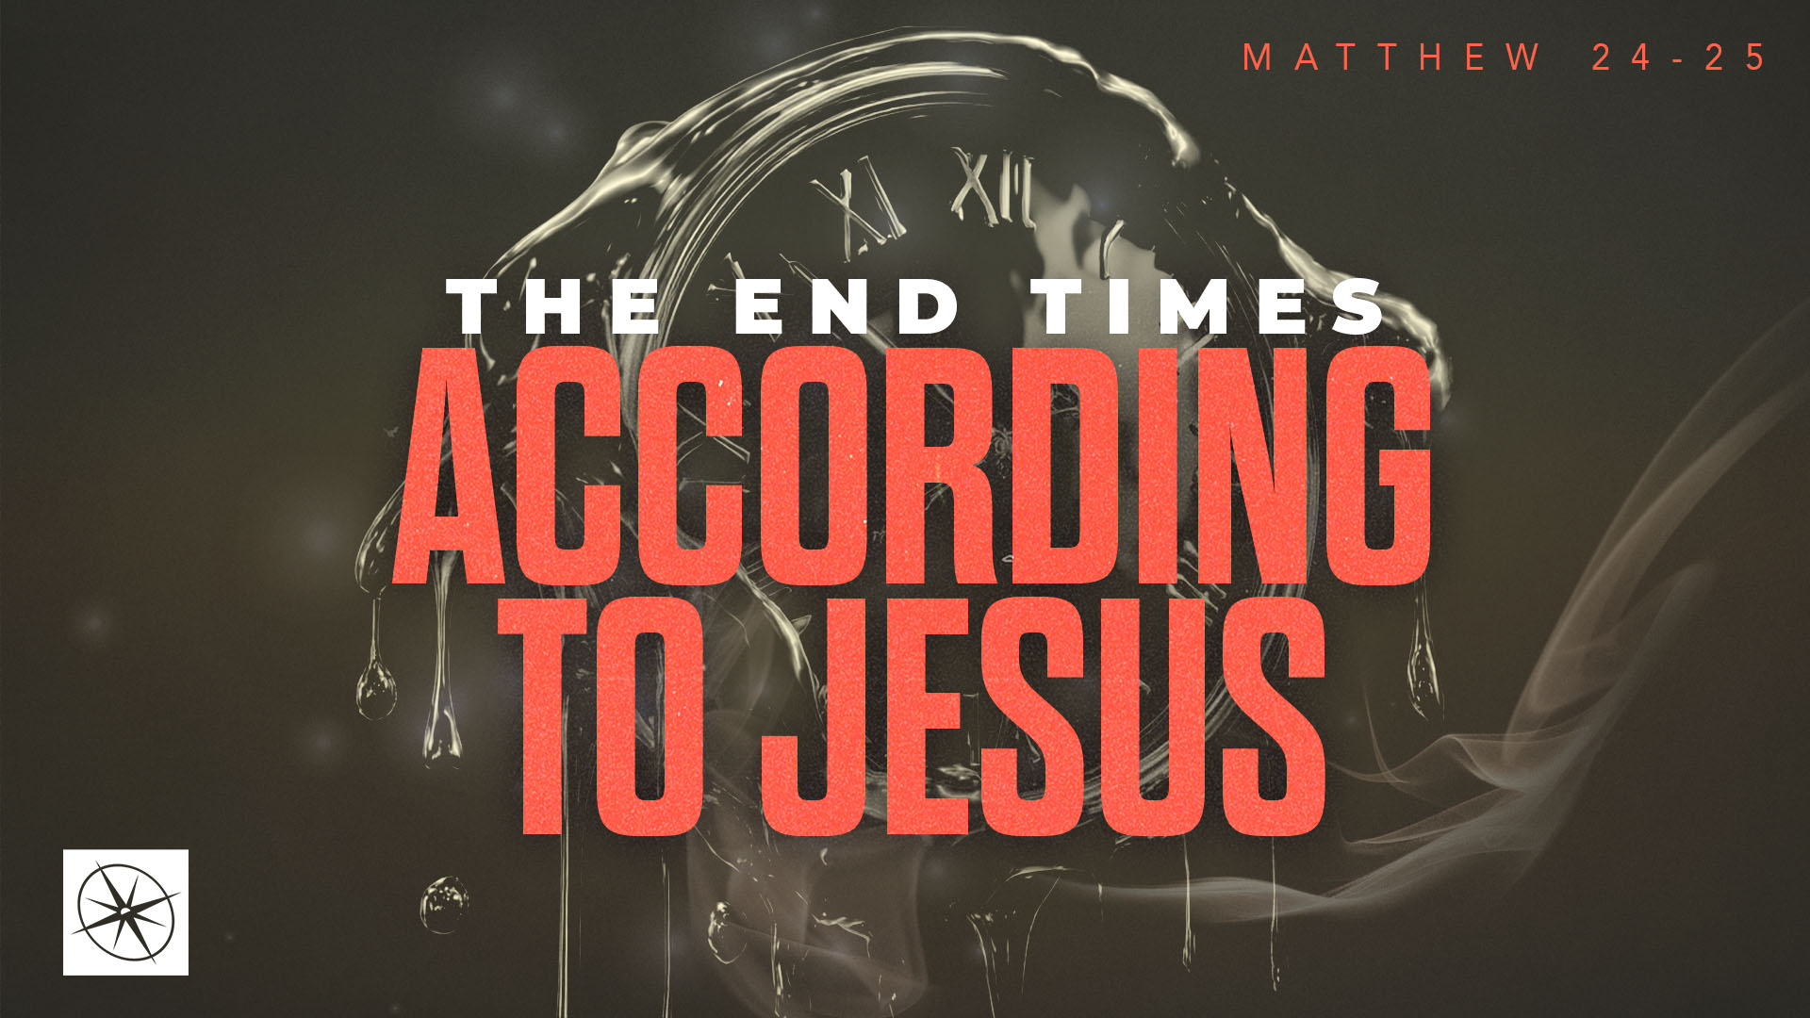
THE END TIMES ACCORDING TO JESUS
THE KING RETURNS
Pastor Hayden Thomas • Compass Bible Church Hill Country • September 13, 2026 • Msg. 26-34

PREACHING POINT: Every Christian should long for the glorious return of Christ, when he will unmistakably appear to judge the nations and establish his kingdom!

Matthew 24:29–31 (ESV)
29 “Immediately after the tribulation of those days the sun will be darkened, and the moon will not give its light, and the stars will fall from heaven, and the powers of the heavens will be shaken. 30 Then will appear in heaven the sign of the Son of Man, and then all the tribes of the earth will mourn, and they will see the Son of Man coming on the clouds of heaven with power and great glory. 31 And he will send out his angels with a loud trumpet call, and they will gather his elect from the four winds, from one end of heaven to the other.

- Remember _______________________________ (v.29)
- Pray ___________________________________ (v.30)
- Look ___________________________________ (v.31)

Application Questions
These questions are provided for your further study and application of today’s sermon. Thoughtfully writing out the answers to these questions will help to drive home the point of today’s study. It is also helpful when you are able to discuss your answers with others. For more information about LifeGroups at Compass Bible Church that utilize these questions as the basis for their weekly discussion, please visit compasshillcountry.org/lifegroups or email us at info@compasshillcountry.org.

1. Write down one observation or application you found helpful from this week’s sermon. Why did it stand out to you?
This Week’s
Bible Reading Schedule
September 13th
Proverbs 23-24 & 2 Corinth 5
September 114th
Proverbs 25-27 & 2 Corinth 6
September 15th
Proverbs 28-29 & 2 Corinth 7
September 16th
Proverbs 30-31 & 2 Corinth 8
September 17th
Ecc 1-3 & 2 Corinth 9
September 18th
Ecc 4-6 & 2 Corinth 10
September 19th
Ecc 7-9 & 2 Corinth 11:1-15
September 20th
Ecc 10-23 & 2 Cor 11:16-33
Have a question about this sermon? Send it via the QR code or link below and the pastors will do their best to address it in this week’s EQUIP podcast.

qrco.de/askaquestion

See this sermon and all Compass-related videos on YouTube.com/
CompassBibleChurchHillCountry
Subscribe to Weekend Sermons, CompassU & LifeGroup Leader Podcasts: compasshillcountry.org/
podcasts

2. Read Psalm 102:25–27, 2 Peter 3:10–13, and 1 John 2:15–17. What do these passages teach about the danger of loving or building your life around anything other than Christ in this fleeting world?
a. Have you been treating anything as permanent that will ultimately pass away? What would holding those things more loosely and investing more deeply in eternity look like practically in your life?
3. Read Matthew 6:9–10 and Daniel 7:13–14. How does Jesus’ instruction to pray “your kingdom come” help you understand what Jesus’ ultimate plan is for the world and your life?
a. How often do you genuinely long for and pray for Christ’s return? What do you think would change in your life if you spent more time praying for Christ’s coming Kingdom?
4. Read Revelation 19:11–16. How does this vision of Christ as the conquering King who judges the nations shape the way you should think about his second coming?
a. Where in your life are you currently resisting the authority of King Jesus, and what would it look like to submit that area to Christ as you anticipate his coming Kingdom?
5. Read Isaiah 27:12–13, Zechariah 12:10–13:1, and 1 Thessalonians 3:13. How does knowing that Christ will gather his elect from across the earth and unite them with those who return with him to establish his kingdom shape the way you persevere in this age as you look forward to the defeat of evil and the triumph of Jesus in the age to come?

