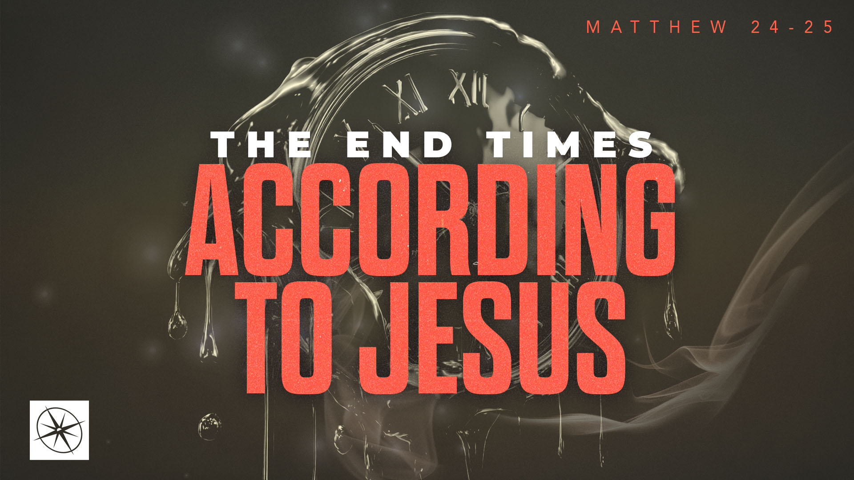
THE END TIMES ACCORDING TO JESUS
A DIVINE CERTAINTY
Pastor Hayden Thomas • Compass Bible Church Hill Country • September 20, 2026 • Msg. 26-35

PREACHING POINT: Knowing Christ’s words will outlast the world should cause you to trust his promises and live for what will last.

Matthew 24:32–35 (ESV)
32 “From the fig tree learn its lesson: as soon as its branch becomes tender and puts out its leaves, you know that summer is near. 33 So also, when you see all these things, you know that he is near, at the very gates. 34 Truly, I say to you, this generation will not pass away until all these things take place. 35 Heaven and earth will pass away, but my words will not pass away.”

- Trust _________________________________ (vv.32-34)
- Invest ___________________________________ (v.35)

Application Questions
These questions are provided for your further study and application of today’s sermon. Thoughtfully writing out the answers to these questions will help to drive home the point of today’s study. It is also helpful when you are able to discuss your answers with others. For more information about LifeGroups at Compass Bible Church that utilize these questions as the basis for their weekly discussion, please visit compasshillcountry.org/lifegroups or email us at info@compasshillcountry.org.

1. Write down one observation or application you found helpful from this week’s sermon. Why did it stand out to you?
This Week’s
Bible Reading Schedule
September 20th
Ecc 10-12 & 2 Cor 11:16-33
September 21st
Song of Sol 1-3 & 2 Corinth 12
September 22nd
Song of Sol 4-5 & 2 Corinth 13
September 23rd
Song of Sol 6-8 & Galatians 1
September 24th
Isaiah 1-3 & 2 Galatians 2
September 25th
Isaiah 4-6 & 2 Galatians 3
September 26th
Isaiah 7-9 & 2 Galatians 4
September 27th
Isaiah 10-12 & Galatians 5
Have a question about this sermon? Send it via the QR code or link below and the pastors will do their best to address it in this week’s EQUIP podcast.

qrco.de/askaquestion

See this sermon and all Compass-related videos on YouTube.com/
CompassBibleChurchHillCountry
Subscribe to Weekend Sermons, CompassU & LifeGroup Leader Podcasts: compasshillcountry.org/
podcasts

2. Read Isaiah 55:10–11 and Isaiah 46:9–10. What do these passages teach about the certainty of God’s Word?
a. What would treating Christ’s words as more certain than even your own death practically look like this week?
3. Christ says, “Heaven and earth will pass away, but my words will not pass away.” What are some things in this world that you are tempted to treat as though they will last forever?
4. Read Matthew 6:19–21 and Colossians 3:1–4. How should the temporary nature of this world change what you value and pursue?
a. If someone examined your calendar, bank account, and topics of discussion from the past month, what might they conclude you are investing your life in?
5. What areas of your life (your time, relationships, money, career, or possessions) do you need to invest more intentionally in what will last?
a. What are one or two specific changes you can make this week to ensure those areas are eternally focused?

