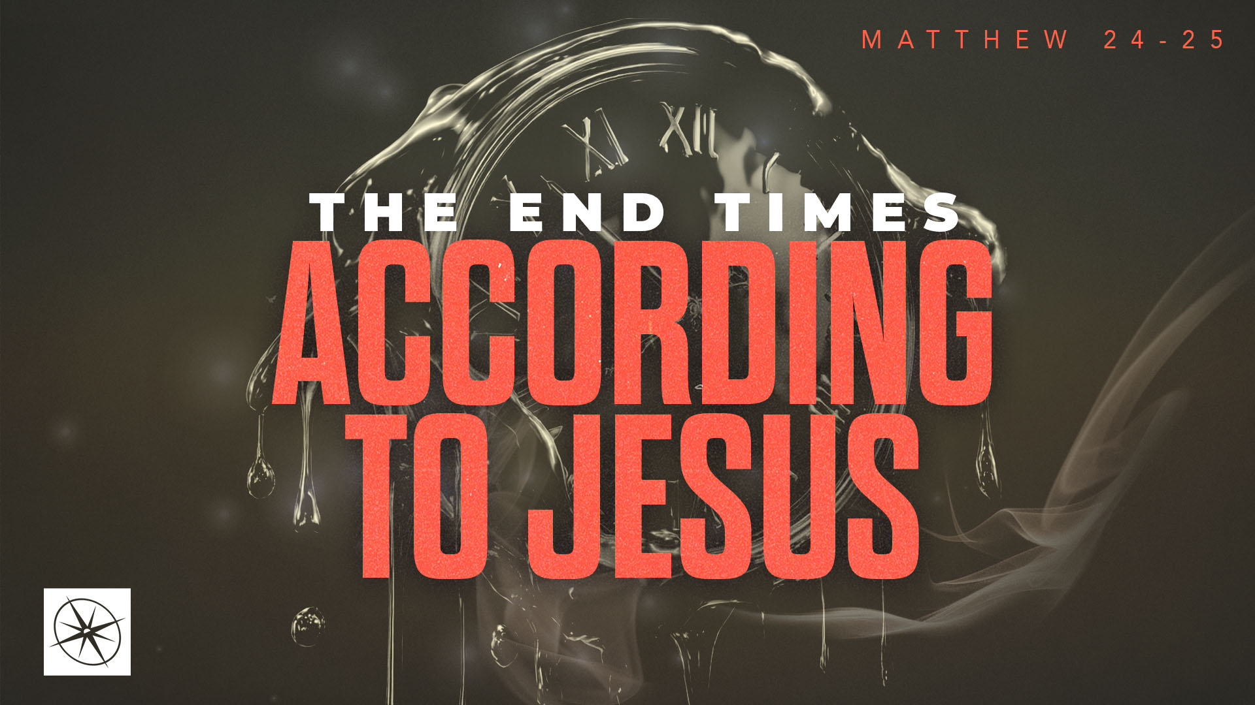
THE END TIMES ACCORDING TO JESUS
WHO KNOWS? BE READY! (PART ONE)
Pastor Hayden Thomas • Compass Bible Church Hill Country • September 27, 2026 • Msg. 26-36

PREACHING POINT: Since we don’t know the day or hour of the end, we must remain vigilant and ready at all times for Christ's return.

Matthew 24:36–44 (ESV)
36 “But concerning that day and hour no one knows, not even the angels of heaven, nor the Son, but the Father only. 37 For as were the days of Noah, so will be the coming of the Son of Man. 38 For as in those days before the flood they were eating and drinking, marrying and giving in marriage, until the day when Noah entered the ark, 39 and they were unaware until the flood came and swept them all away, so will be the coming of the Son of Man. 40 Then two men will be in the field; one will be taken and one left. 41 Two women will be grinding at the mill; one will be taken and one left. 42 Therefore, stay awake, for you do not know on what day your Lord is coming. 43 But know this, that if the master of the house had known in what part of the night the thief was coming, he would have stayed awake and would not have let his house be broken into. 44 Therefore you also must be ready, for the Son of Man is coming at an hour you do not expect.

- Don’t _________________________________ (v.36)
- Stay ________________________________ (vv.37-42)
- Stay ________________________________ (vv.43-44)

Application Questions
These questions are provided for your further study and application of today’s sermon. Thoughtfully writing out the answers to these questions will help to drive home the point of today’s study. It is also helpful when you are able to discuss your answers with others. For more information about LifeGroups at Compass Bible Church that utilize these questions as the basis for their weekly discussion, please visit compasshillcountry.org/lifegroups or email us at info@compasshillcountry.org.

1. Write down one observation or application you found helpful from this week's sermon. Why did it stand out to you?
This Week’s
Bible Reading Schedule
September 27th
Isaiah 10-12 & Galatians 5
September 28th
Isaiah 13-15 & Galatians 6
September 29th
Isaiah 16-18 & Ephesians 1
September 30th
Isaiah 19-21 & Ephesians 2
October 1st
Isaiah 22-23 & Ephesians 3
October 2nd
Isaiah 24-26 & 2 Ephesians 4
October 3rd
Isaiah 27-28 & Ephesians 5
October 4th
Isaiah 29-30 & Ephesians 6
Have a question about this sermon? Send it via the QR code or link below and the pastors will do their best to address it in this week’s EQUIP podcast.

qrco.de/askaquestion

See this sermon and all Compass-related videos on YouTube.com/
CompassBibleChurchHillCountry
Subscribe to Weekend Sermons, CompassU & LifeGroup Leader Podcasts: compasshillcountry.org/
podcasts

2. Read Deuteronomy 29:29 and Acts 1:6–8. How can focusing on what God has not revealed about Christ’s return distract you from what he has clearly commanded you to do?
a. How does continual vigilance concerning the return of Christ help you prioritize and advance in your mission to make disciples today?
3. Read Luke 17:26–30, Luke 21:34–36, and 1 Thessalonians 5:1–6. How does being consumed with the ordinary concerns of life cause you to become spiritually asleep regarding the return of Christ?
a. Which parts of your life most easily distract you spiritually — work, entertainment, money, your kids’ schedules, relationships, possessions, or something else?
b. What does staying spiritually “awake and sober” look like for you this week?
4. Read Titus 2:11–13, 1 John 3:2–3, and 2 Peter 3:11–14. What do these passages say should characterize a Christian who is preparing to meet Christ?
a. What areas of your life need greater spiritual discipline so that you are living prepared to meet Christ?

