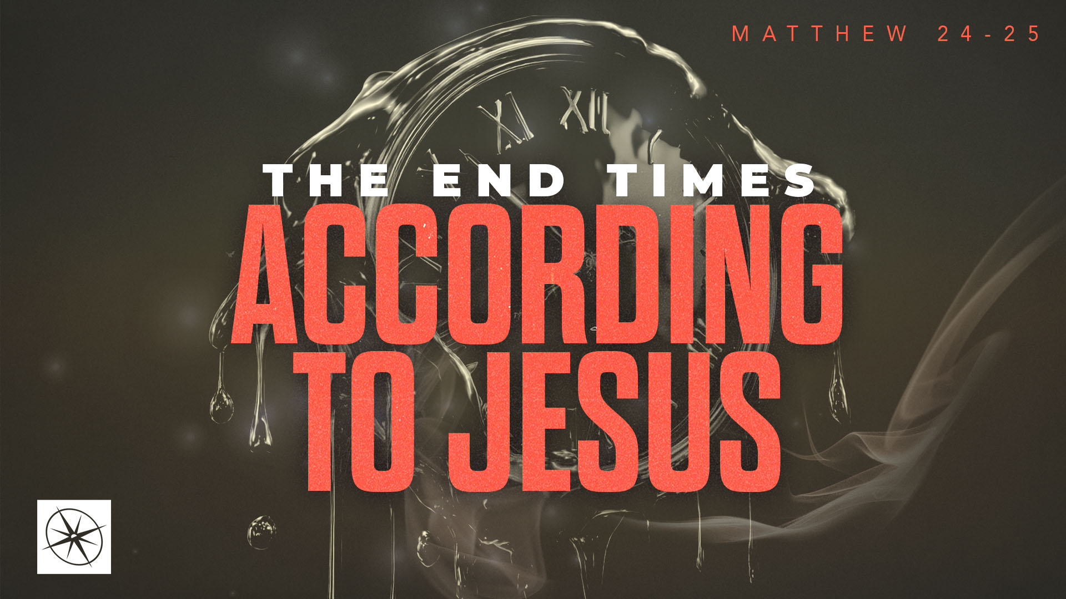
THE END TIMES ACCORDING TO JESUS
THE TIPPING POINT
Pastor Hayden Thomas • Compass Bible Church Hill Country • September 6, 2026 • Msg. 26-33

PREACHING POINT: Jesus’ warnings to those living during the Tribulation should compel us to remain watchful in our own day as we eagerly await Christ’s return to abolish evil and establish his Kingdom.

Matthew 24:15–28 (ESV)
15 “So when you see the abomination of desolation spoken of by the prophet Daniel, standing in the holy place (let the reader understand), 16 then let those who are in Judea flee to the mountains. 17 Let the one who is on the housetop not go down to take what is in his house, 18 and let the one who is in the field not turn back to take his cloak. 19 And alas for women who are pregnant and for those who are nursing infants in those days! 20 Pray that your flight may not be in winter or on a Sabbath. 21 For then there will be great tribulation, such as has not been from the beginning of the world until now, no, and never will be. 22 And if those days had not been cut short, no human being would be saved. But for the sake of the elect those days will be cut short. 23 Then if anyone says to you, ‘Look, here is the Christ!’ or ‘There he is!’ do not believe it. 24 For false christs and false prophets will arise and perform great signs and wonders, so as to lead astray, if possible, even the elect. 25 See, I have told you beforehand. 26 So, if they say to you, ‘Look, he is in the wilderness,’ do not go out. If they say, ‘Look, he is in the inner rooms,’ do not believe it. 27 For as the lightning comes from the east and shines as far as the west, so will be the coming of the Son of Man. 28 Wherever the corpse is, there the vultures will gather.

- Scripturally _______________________________ (v.15)
- Grasp ________________________________ (vv.16-22)
- Keep _________________________________ (vv.23-28)

Application Questions
These questions are provided for your further study and application of today’s sermon. Thoughtfully writing out the answers to these questions will help to drive home the point of today’s study. It is also helpful when you are able to discuss your answers with others. For more information about LifeGroups at Compass Bible Church that utilize these questions as the basis for their weekly discussion, please visit compasshillcountry.org/lifegroups or email us at info@compasshillcountry.org.

1. Write down one observation or application you found helpful from this week's sermon. Why did it stand out to you?
This Week’s
Bible Reading Schedule
September 6th
Proverbs 9-10 & 1 Cor 15:1-32
September 7th
Prov 11-12 & 1 Cor 15:33-58
September 8th
Proverbs 13-14 & 1 Corinth 16
September 9th
Proverbs 15-16 & 2 Corinth 1
September 10th
Proverbs 17-18 & 2 Corinth 2
September 11th
Proverbs 19-20 & 2 Corinth 3
September 12th
Proverbs 21-22 & 2 Corinth 4
September 13th
Proverbs 23-24 & 2 Corinth 5
Have a question about this sermon? Send it via the QR code or link below and the pastors will do their best to address it in this week’s EQUIP podcast.

qrco.de/askaquestion

See this sermon and all Compass-related videos on YouTube.com/
CompassBibleChurchHillCountry
Subscribe to Weekend Sermons, CompassU & LifeGroup Leader Podcasts: compasshillcountry.org/
podcasts

2. Read Matthew 24:15, Mark 13:14, Daniel 9:24–27 and 2 Thessalonians 2:1–4. What do these passages teach you about the identity of the abomination of desolation? Why is understanding this future event important for Christians?
3. Read Matthew 24:16–22. What does Jesus’ description of the Great Tribulation teach you about the severity of God’s future judgment?
a. Matthew 24:22 shows that even the most severe period of human suffering will operate within limits established by God. What do these limits teach you about God’s sovereignty over evil and suffering and his mercy toward those he loves?
4. Read Matthew 24:23–27. According to this passage, why will those living during the Tribulation not need anyone to convince them that Christ has returned?
a. How does Jesus’ description of his unmistakable return help you evaluate claims that Christ has already returned or that the events described in this passage have already been completely fulfilled?
5. Read Titus 2:11–14 and 1 Thessalonians 1:9–10. What is the difference between eagerly awaiting the return of Christ versus simply agreeing that he will return someday?
a. What should eagerly waiting for Christ’s return look like in your life right now?
6. As one pastor once put it: “The plain things are the main things and the main things are the plain things.” How can this principle help you keep your eschatology in its proper perspective as you pursue greater biblical clarity while maintaining unity with other believers?

