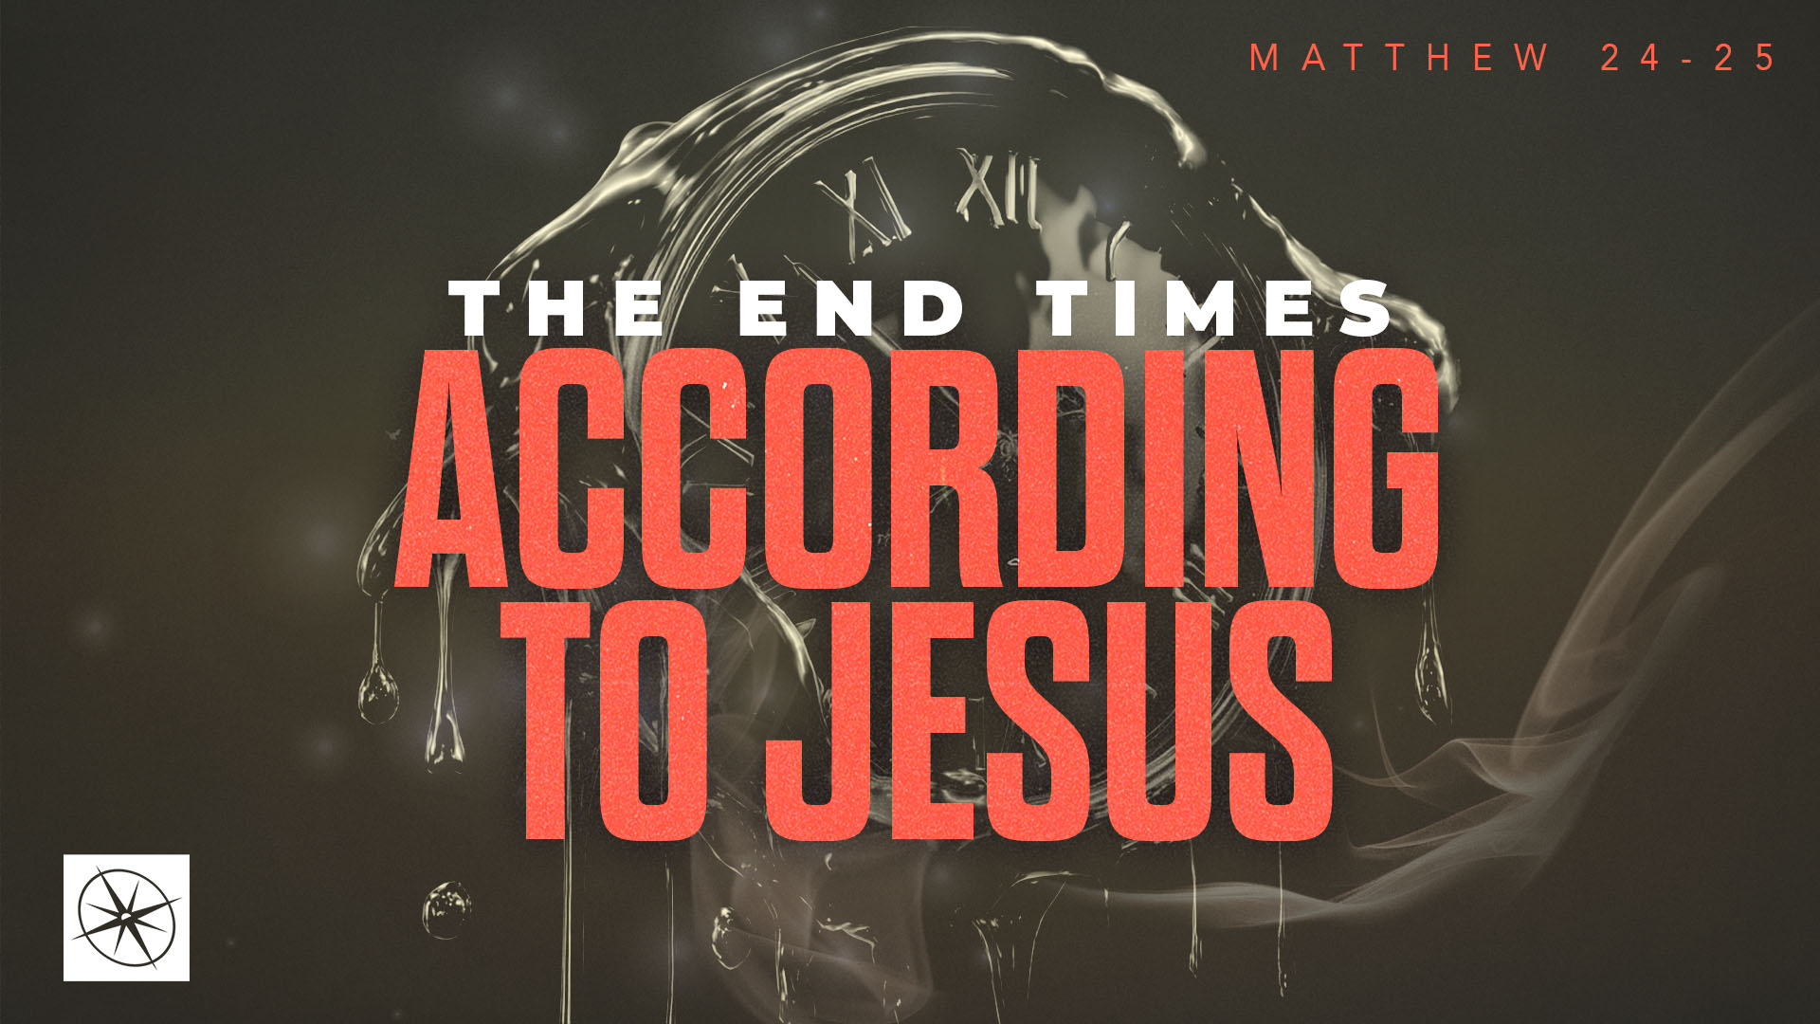
THE END TIMES ACCORDING TO JESUS
ARE YOU PREPARED?
Pastor Hayden Thomas • Compass Bible Church Hill Country • October 11, 2026 • Msg. 26-38

PREACHING POINT: You must spiritually prepare to meet Christ, or risk being left out of the Kingdom of Heaven.

Matthew 25:1–13 (ESV)
1 “Then the kingdom of heaven will be like ten virgins who took their lamps and went to meet the bridegroom. 2 Five of them were foolish, and five were wise. 3 For when the foolish took their lamps, they took no oil with them, 4 but the wise took flasks of oil with their lamps. 5 As the bridegroom was delayed, they all became drowsy and slept. 6 But at midnight there was a cry, ‘Here is the bridegroom! Come out to meet him.’ 7 Then all those virgins rose and trimmed their lamps. 8 And the foolish said to the wise, ‘Give us some of your oil, for our lamps are going out.’ 9 But the wise answered, saying, ‘Since there will not be enough for us and for you, go rather to the dealers and buy for yourselves.’ 10 And while they were going to buy, the bridegroom came, and those who were ready went in with him to the marriage feast, and the door was shut. 11 Afterward the other virgins came also, saying, ‘Lord, lord, open to us.’ 12 But he answered, ‘Truly, I say to you, I do not know you.’ 13 Watch therefore, for you know neither the day nor the hour.

- Don’t _________________________________ (vv. 1-5)
- Don’t ________________________________ (vv. 6-12)
- Stay ________________________________ (vv. 10-13)

Application Questions
These questions are provided for your further study and application of today’s sermon. Thoughtfully writing out the answers to these questions will help to drive home the point of today’s study. It is also helpful when you are able to discuss your answers with others. For more information about LifeGroups at Compass Bible Church that utilize these questions as the basis for their weekly discussion, please visit compasshillcountry.org/lifegroups or email us at info@compasshillcountry.org.

- Write down one observation or application you found helpful from this week's sermon. Why did it stand out to you?
This Week’s
Bible Reading Schedule
October 11th
Isaiah 45-47 & Colossians 3
October 12th
Isaiah 48-49 & Colossians 4
October 13th
Isaiah 50-52 & 1 Thess 1
October 14th
Isaiah 53-55 & 1 Thess 2
October 15th
Isaiah 56-58 & 1 Thess 3
October 16th
Isaiah 59-61 & 1 Thess 4
October 17th
Isaiah 62-64 & 1 Thess 5
October 18th
Isaiah 65-66 & 2 Thess 1
Have a question about this sermon? Send it via the QR code or link below and the pastors will do their best to address it in this week’s EQUIP podcast.

qrco.de/askaquestion

See this sermon and all Compass-related videos on YouTube.com/
CompassBibleChurchHillCountry
Subscribe to Weekend Sermons, CompassU & LifeGroup Leader Podcasts: compasshillcountry.org/
podcasts

- Read Hebrews 4:1–7 and Isaiah 55:6–7. Why is “rolling the dice” and delaying your preparation to meet Jesus dangerous?

- What current area in your life (i.e., salvation, obedience, repentance, forgiveness, etc.) do you need to address to prepare yourself spiritually to meet Jesus face-to-face?

- Read Matthew 25:7–12 and Matthew 7:21–23. Why might someone expect to enter Christ’s Kingdom and yet be excluded?

- What distinguishes false assurance, which is excluded from Christ’s Kingdom, from saving faith, which enters Christ’s Kingdom?

b. What does staying spiritually “awake and sober” look like for you this week?
- Even as a genuine believer, how might you become overly dependent on someone else's spiritual maturity (a spouse, parent, etc.) rather than cultivating your own relationship with Christ?

- Read Romans 13:11–14 and Luke 12:35–38. What does maintaining a constant readiness to meet Jesus look like?

