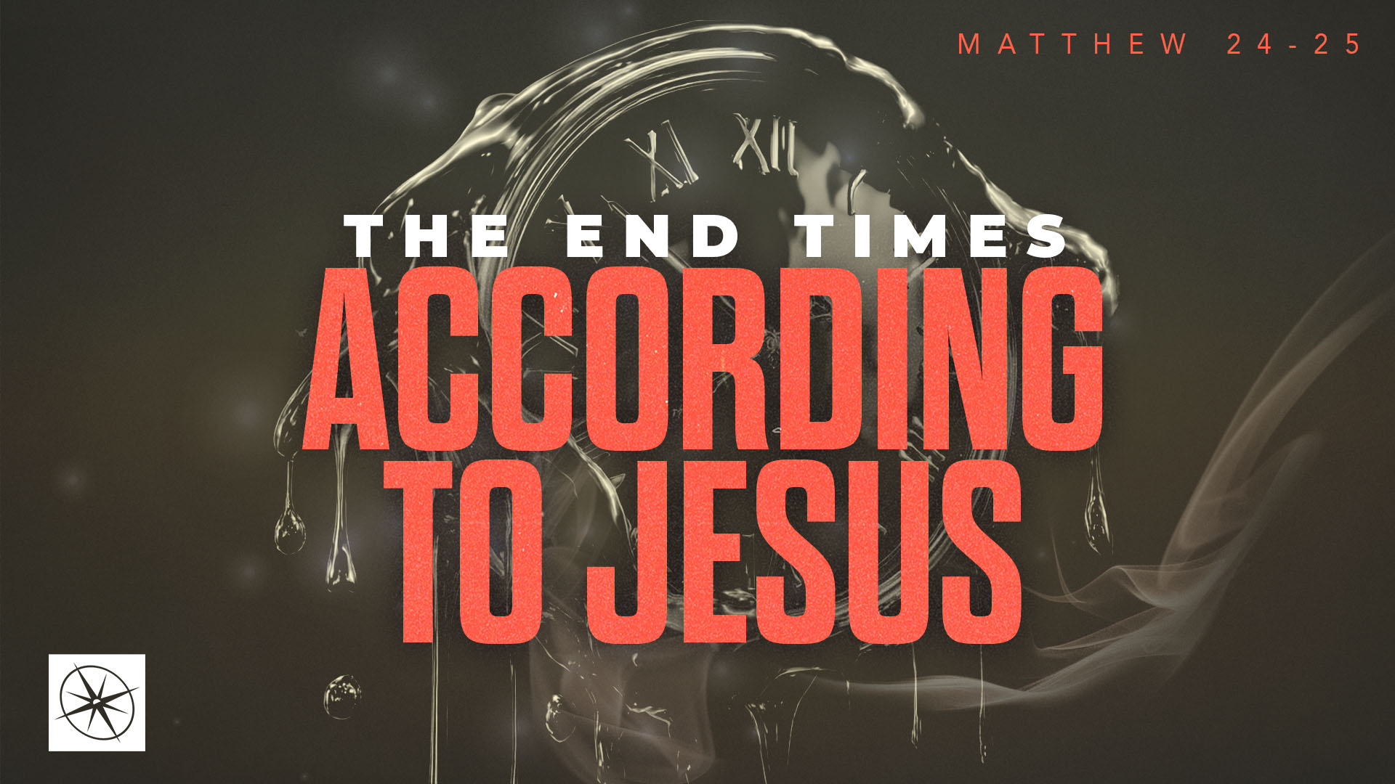
THE END TIMES ACCORDING TO JESUS
STEWARDSHIP IN THE ITERIM
Pastor Hayden Thomas • Compass Bible Church Hill Country • October 4, 2026 • Msg. 26-37

PREACHING POINT: Knowing our Master will return should motivate us to faithfully steward what he has entrusted to us while he is away.

Matthew 24:45–51 (ESV)
45 “Who then is the faithful and wise servant, whom his master has set over his household, to give them their food at the proper time? 46 Blessed is that servant whom his master will find so doing when he comes. 47 Truly, I say to you, he will set him over all his possessions. 48 But if that wicked servant says to himself, ‘My master is delayed,’ 49 and begins to beat his fellow servants and eats and drinks with drunkards, 50 the master of that servant will come on a day when he does not expect him and at an hour he does not know 51 and will cut him in pieces and put him with the hypocrites. In that place there will be weeping and gnashing of teeth.

- Know ___________________________________ (v.45)
- Expect ________________________________ (vv.46-47)
- Expect ________________________________ (vv.48-51)

Application Questions
These questions are provided for your further study and application of today’s sermon. Thoughtfully writing out the answers to these questions will help to drive home the point of today’s study. It is also helpful when you are able to discuss your answers with others. For more information about LifeGroups at Compass Bible Church that utilize these questions as the basis for their weekly discussion, please visit compasshillcountry.org/lifegroups or email us at info@compasshillcountry.org.

1. Write down one observation or application you found helpful from this week’s sermon. Why did it stand out to you?
This Week’s
Bible Reading Schedule
October 4th
Isaiah 29-30 & Ephesians 6
October 5th
Isaiah 31-33 & Philippians 1
October 6th
Isaiah 34-36 & Philippians 2
October 7th
Isaiah 37-38 & Philippians 3
October 8th
Isaiah 39-40 & Philippians 4
October 9th
Isaiah 41-42 & 2 Colossians 1
October 10th
Isaiah 43-44 & Colossians 2
October 11th
Isaiah 45-47 & Colossians 3
Have a question about this sermon? Send it via the QR code or link below and the pastors will do their best to address it in this week’s EQUIP podcast.

qrco.de/askaquestion

See this sermon and all Compass-related videos on YouTube.com/
CompassBibleChurchHillCountry
Subscribe to Weekend Sermons, CompassU & LifeGroup Leader Podcasts: compasshillcountry.org/
podcasts

2. Read 1 Corinthians 4:1–2 and Romans 13:11–14. What would it look like for you to live this week with a greater awareness that God has entrusted your life to you as a stewardship for his Kingdom?
a. In what area of your life are you most tempted to act like an owner rather than a steward? How can you change that this week?
3. Read Revelation 22:12 and 1 Corinthians 3:10–15. Why should the prospect of Christ rewarding his servants at his return motivate you toward greater faithfulness?
a. What area is the Holy Spirit currently convicting you to choose eternal reward over immediate gratification?
4. Read Matthew 25:14–30. What does the “Parable of the Talents” teach you about God’s ownership of your life and your accountability for what he has entrusted you?
a. How should you think about your life, resources, relationships and salvation as stewardships that God has given you with expectations that you produce a return for the Kingdom of God?
5. Read Luke 12:47–48 and 2 Peter 3:3–7. Does the certainty of God’s judgment toward those who reject God motivate you evangelistically? Why or why not?
a. How can you use these passages, or others like it, to compassionately show an unbeliever that God is going to judge their rejection of the gospel with specificity and perfect justice?

