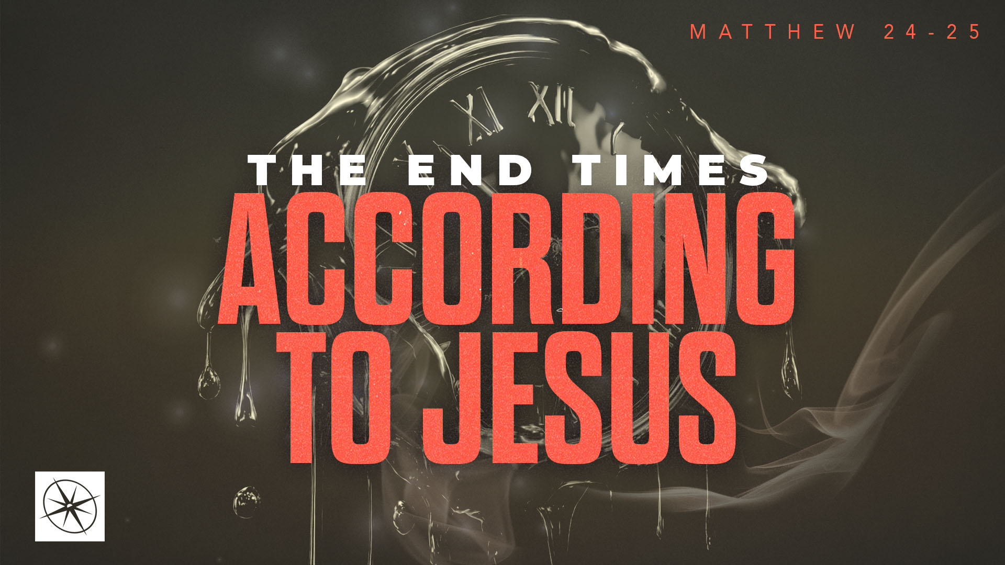
THE END TIMES ACCORDING TO JESUS
THE GREAT SEPARATION PART 2
Pastor Hayden Thomas • Compass Bible Church Hill Country • November 8, 2026 • Msg. 26-42

PREACHING POINT: We must cultivate and maintain a visceral fear of the eternal consequences awaiting those who reject Christ and his people.

Matthew 25:41–46 (ESV)
41 “Then he will say to those on his left, ‘Depart from me, you cursed, into the eternal fire prepared for the devil and his angels. 42 For I was hungry and you gave me no food, I was thirsty and you gave me no drink, 43 I was a stranger and you did not welcome me, naked and you did not clothe me, sick and in prison and you did not visit me.’ 44 Then they also will answer, saying, ‘Lord, when did we see you hungry or thirsty or a stranger or naked or sick or in prison, and did not minister to you?’ 45 Then he will answer them, saying, ‘Truly, I say to you, as you did not do it to one of the least of these, you did not do it to me.’ 46 And these will go away into eternal punishment, but the righteous into eternal life.”

- Grasp _________________________________ (v.41)
- Observe ______________________________ (vv.42-45)
- Comprehend _____________________________ (v.46)

Application Questions
These questions are provided for your further study and application of today’s sermon. Thoughtfully writing out the answers to these questions will help to drive home the point of today’s study. It is also helpful when you are able to discuss your answers with others. For more information about LifeGroups at Compass Bible Church that utilize these questions as the basis for their weekly discussion, please visit compasshillcountry.org/lifegroups or email us at info@compasshillcountry.org.

- Read Matthew 25:41–46. Write down one observation or application you found helpful from this week’s sermon. Why did it stand out to you?
This Week’s
Bible Reading Schedule
November 8th
Jeremiah 49-50 & Hebrews 5
November 9th
Jeremiah 51-52 & Hebrews 6
November 10th
Lamentations 1-2 & Hebrews 7
November 11th
Lamentations 3-5 & Hebrews 8
November 12th
Ezekiel 1-3 & Hebrews 9
November 13th
Ezekiel 4-6 & Hebrews 10:1-23
November 14th
Ezekiel 7-9 & Heb 10:24-29
November 15th
Ezekiel 10-12 & Heb 11:1-19
Have a question about this sermon? Send it via the QR code or link below and the pastors will do their best to address it in this week’s EQUIP podcast.

qrco.de/askaquestion

See this sermon and all Compass-related videos on YouTube.com/
CompassBibleChurchHillCountry
Subscribe to Weekend Sermons, CompassU & LifeGroup Leader Podcasts: compasshillcountry.org/
podcasts

- Read Luke 12:4–5 and 2 Thessalonians 1:6–10. What do these passages teach about the severity of Christ’s judgment toward those who reject him, and why is a healthy fear of that judgment appropriate?
  - How should a sober view of hell shape the way you think about the people in your life who do not know Christ? Who can you pray for and pursue with the gospel this week in light of the severity of hell?
- Read John 13:34–35 and 1 John 3:13–18. How does the reminder that your treatment of other believers reveals your relationship with Christ serve as a heart-check for you?
- Read John 15:18–21 and 1 Peter 4:12–14. Why should Christians expect ridicule and rejection from unbelievers, and how can you prepare for these responses so you aren’t surprised when they happen?
- Read John 5:28–29 and Daniel 12:1–3. How can regularly reminding yourself of the finality of Christ’s judgment help you grow in your faith and become more intentional in evangelism?

