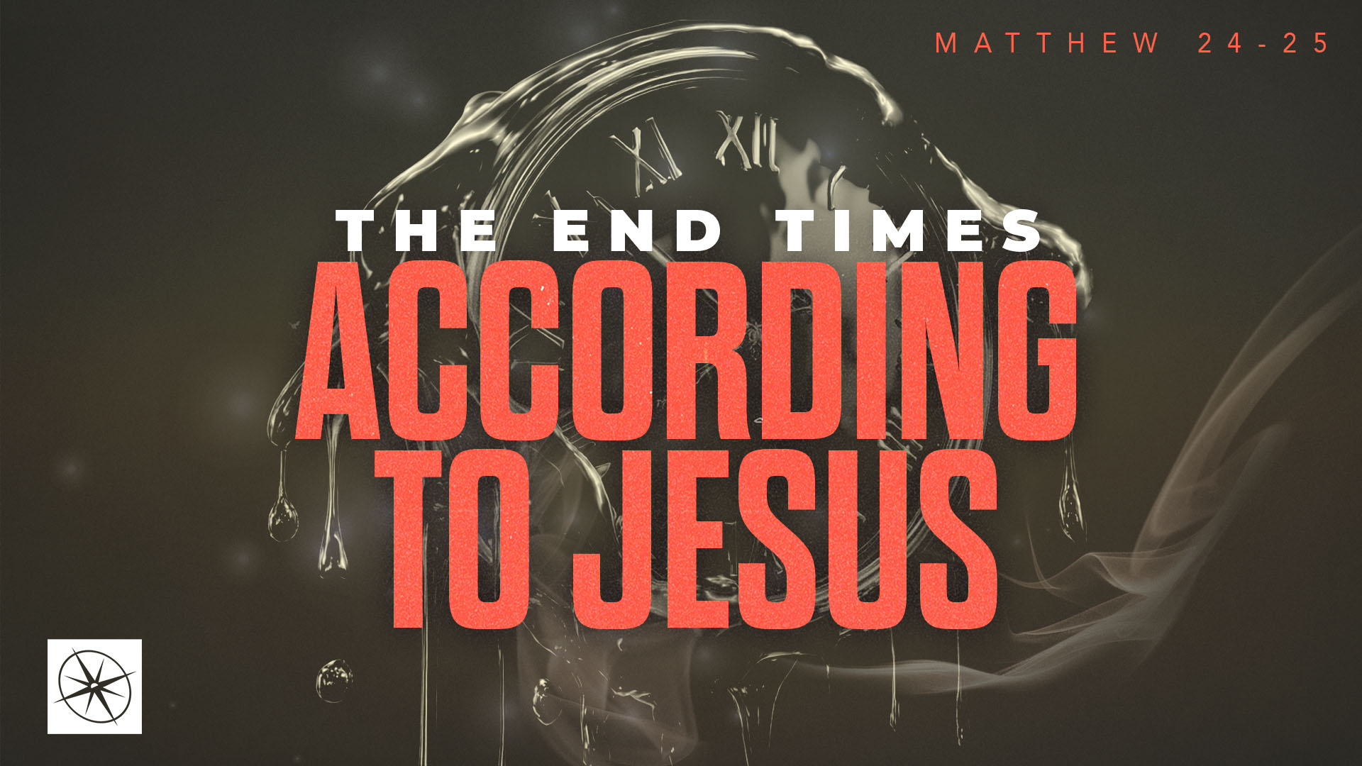
THE END TIMES ACCORDING TO JESUS
THE GREAT SEPARATION PART 1
Pastor Hayden Thomas • Compass Bible Church Hill Country • November 1, 2026 • Msg. 26-41

PREACHING POINT: Knowing that Christ will separate those alive after the Tribulation based on how they serve Jesus’ brothers should remind us how much God cares about the way we demonstrate our faith by serving his people today.

Matthew 25:31–40 (ESV)
31 “When the Son of Man comes in his glory, and all the angels with him, then he will sit on his glorious throne. 32 Before him will be gathered all the nations, and he will separate people one from another as a shepherd separates the sheep from the goats. 33 And he will place the sheep on his right, but the goats on the left. 34 Then the King will say to those on his right, ‘Come, you who are blessed by my Father, inherit the kingdom prepared for you from the foundation of the world. 35 For I was hungry and you gave me food, I was thirsty and you gave me drink, I was a stranger and you welcomed me, 36 I was naked and you clothed me, I was sick and you visited me, I was in prison and you came to me.’ 37 Then the righteous will answer him, saying, ‘Lord, when did we see you hungry and feed you, or thirsty and give you drink? 38 And when did we see you a stranger and welcome you, or naked and clothe you? 39 And when did we see you sick or in prison and visit you?’ 40 And the King will answer them, ‘Truly, I say to you, as you did it to one of the least of these my brothers, you did it to me.’

- Recognize _____________________________ (vv.31-32)
- Consider ______________________________ (vv.33-36)
- Serve _______________________________ (vv.37-40)

Application Questions
These questions are provided for your further study and application of today’s sermon. Thoughtfully writing out the answers to these questions will help to drive home the point of today’s study. It is also helpful when you are able to discuss your answers with others. For more information about LifeGroups at Compass Bible Church that utilize these questions as the basis for their weekly discussion, please visit compasshillcountry.org/lifegroups or email us at info@compasshillcountry.org.

- Read Matthew 25:31–40. Write down one observation or application you found helpful from this week’s sermon. Why did it stand out to you?
This Week’s
Bible Reading Schedule
November 1st
Jeremiah 31-32 & Titus 2
November 2nd
Jeremiah 33-35 & Titus 3
November 3rd
Jeremiah 36-37 & Philemon
November 4th
Jeremiah 38-39 & Hebrews 1
November 5th
Jeremiah 40-42 & Hebrews 2
November 6th
Jeremiah 43-45 & Hebrews 3
November 7th
Jeremiah 46-48 & Hebrews 4
November 8th
Jeremiah 49-50 & Hebrews 5
Have a question about this sermon? Send it via the QR code or link below and the pastors will do their best to address it in this week’s EQUIP podcast.

qrco.de/askaquestion

See this sermon and all Compass-related videos on YouTube.com/
CompassBibleChurchHillCountry
Subscribe to Weekend Sermons, CompassU & LifeGroup Leader Podcasts: compasshillcountry.org/
podcasts

- Read Daniel 7:13–14 and Acts 17:30–31. What do these passages teach about Christ's authority to judge, and how should knowing that you will answer to him, even as a Christian influence the way you live today?
- Read Ephesians 2:8–10 and James 2:14–17. How do these passages distinguish the basis of our salvation from the evidence of genuine faith?
  - What evidence of saving faith should be increasingly evident in your life?
- Read Matthew 10:40–42 and Galatians 6:9–10. How should knowing that Christ identifies himself with his people change the way you serve fellow Christians?
  - In what practical ways do you currently serve Christ through serving his people, or how do you plan to do so moving forward?

